**TECHNICAL LANGUAGE**



**Author: Tai Nguyen**

**Date: 12/24/2016**

**Revision history**

|  |  |  |  |
| --- | --- | --- | --- |
| **Version** | **Date** | **Author** | **Notes** |
| **1.0** | 12/24/2016 | Tai Nguyen | Create document |
| 1.1 | 1/8/2016 | Tai Nguyen | Update |
| 1.2 | 1/24/2016 | Tai Nguyen, Phuong Nguyen | Update |

Contents

I. STANDINGS CURRENT PROGRAMMING LANGUAGE 3

II. THE LANGUAGE USED FOR THE PROPOSED PROJECT 4

III. ASSESSMENT OF CONFORMITY OF THE 5 LANGUAGES FOR PROJECT 5

IV. TECHNOLOGY REVIEW FITNESS FOR ONGOING PROJECTS (CRITERIA PRODUCT) 8

V. EVALUATION DATABASE 9

VI. PASS/FAIL CRITERIA 10

VII. SUMMARY 10

# STANDINGS CURRENT PROGRAMMING LANGUAGE

## IEEE Spectrum rated the programming language 2016. Spectrum most popular language assessment across 12 indicators, each indicator considering the popularity in a different direction. Combining indicators for the ranking of language.

## Since each person can view various important aspects, interactive tools of Spectrum's Top Programming Languages allows you to adjust the weight of each of the index contributed to the ranking. There's also a filter option: for example, just consider the language used in embedded systems or mobile applications. You can customize the weight of each index or use the available settings.

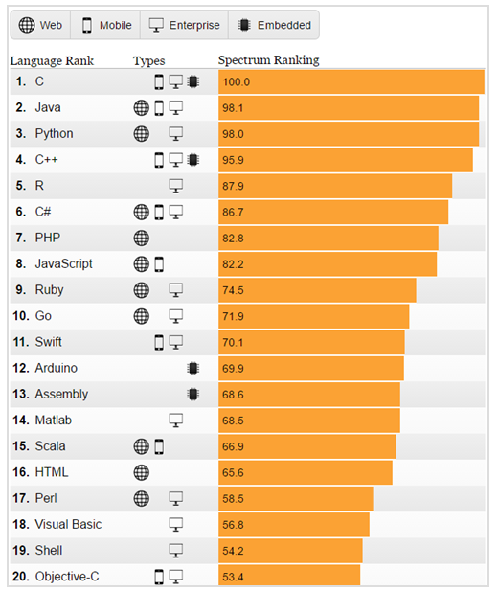

# THE LANGUAGE USED FOR THE PROPOSED PROJECT

According to the project scope implementation is a skill swap website and web app growing up. Should filter out certain groups are expected to use language specific (with a score of 80 or higher Ranking Spectrum):

|  |  |  |
| --- | --- | --- |
| **Language** | **Types** | **Spectrum Ranking** |
| 1 Java | Web, Mobile, Enterprise | 98.1 |
| 2 Paython | Web, Enterprise | 98.0 |
| 3 C# | Web, Mobile, Enterprise | 86.7 |
| 4 PHP | Web | 82.8 |
| 5 JavaScript | Web, Mobile | 82.2 |

After putting the choice is, the group has launched five languages can bring success for promising projects.

# ASSESSMENT OF CONFORMITY OF THE 5 LANGUAGES FOR PROJECT

* **Use Database:**

|  |  |
| --- | --- |
| **Language** | **Database** |
| 1 Java | JDBC (Java Database Connectivity) |
| 2 Paython | SQLite, MySQL |
| 3 C# | MySQL, SQL Server |
| 4 PHP | MySQL, SQL Server |
| 5 JavaScipt | JDBC (Java Database Connectivity) |

JDBC stands for Java Database Connectivity, is a standard Java API for connectivity between the Java programming language and the various databases. Using JDBC, you can perform many varied tasks when working with databases such as creating, deleting databases; create and execute SQL or MySQL; create, delete records; ...

<http://vietjack.com/java_jdbc/tong_quan_ve_jdbc.jsp>

|  |  |  |  |  |  |
| --- | --- | --- | --- | --- | --- |
| **Language** | **Java** | **Paython** | **C#** | **PHP** | **JavaScript** |
| **Point** | 5 | 4 | 4 | 4 | 5 |

Grading criteria:

1: Terrible

2: Not good

3: Normal

4: Good

5: Excellent

5 languages are used by the database is quite good, but with Java and JavaScript, it is somewhat remarkable, since two languages can use JDBC connections use many different database types.

* **Framework support:**

The languages supported are the framework for the implementation of the package. Thanks to the support framework that the implementation of software projects faster and get a working framework. On the other hand we get a clean source, ease of development and maintenance. (Follow <https://blog.duyetdev.com/2014/06/php-framework-la-gi-tai-sao-nen-dung.html#.WJk8PlWLTIU>)

|  |  |  |  |  |  |
| --- | --- | --- | --- | --- | --- |
| **Language** | **Java** | **Paython** | **C#** | **PHP** | **JavaScript** |
| **Point** | 4 | 4 | 5 | 5 | 4 |

Grading criteria:

1: No

2: Very few

3: Little

4: Many

5: A lot of

Talking about the use of the framework to support the implementation, you can see is the superiority of C # and PHP. 2 this language framework supports working warehouse giant and still in a state of development have the potential to add up. But this is probably the downside of 2 languages. As development projects meant to use the older version, the framework is quite difficult in the development, from the compatibility to function until the update of the version.

* **Calculating Performance for the project:**

With the support of the framework, the programming language to write Web have helped increase mobility and Performance for software products.

|  |  |  |  |  |  |
| --- | --- | --- | --- | --- | --- |
| **Language** | **Java** | **Paython** | **C#** | **PHP** | **JavaScript** |
| **Point** | 5 | 4 | 4 | 4 | 5 |

Grading criteria:

1: Few

2: Little

3: Normal

4: Good

5: Excellent

2 Java and JavaScript are two language communities most programming choices, for two languages ​​is the main platform for the introduction of colorful interface. 2 this language is very popular because of the advent lot beautiful game interface easy to use user attracted. Not only that, this language was 2 main platform for advanced graphics technology and virtual reality architecture.

Java and JavaScript are seemingly equal and the same, but actually two languages ​​differ greatly (2 languages ​​to follow two different ways). When used as a java web, it will be a lot of difficulties due to run pretty much plug-ins (plug-ins that have been proven to be unsafe and bad). What about JavaScript is the programming language used by the site and do not use the plug-in for approval, should help the web product works faster and better. (Follow <http://thegioitinhoc.vn/thiet-ke-web/258905-thegioitinhoc-vn-java-va-javascript-khac-nhau-hay-cung-mot-aoegiuoca.html> )

* **As availability for product:**

|  |  |  |  |  |  |
| --- | --- | --- | --- | --- | --- |
| **Language** | **Java** | **Paython** | **C#** | **PHP** | **JavaScript** |
| **Point** | 5 | 4 | 3 | 4 | 5 |

Grading criteria:

1: Few

2: Little

3: Normal

4: Good

5: Excellent

Java and JavaScript 2 language can speak 2 languages are born pretty simple products to these masterpieces. The remaining 3 languages also have products equally. But C # to be slipping crutches in this respect because there is little dramatic breakthrough stimulates the user's hard because framework structure, C # is the language used is the main framewpk. Paython and PHP are not bound much. But also the somewhat limited availability on the increase.

* **As Security in the product:**

Security high or low depending on the largest of the language of architecture. As everyone already knows, C # core is hard Framewok default structure should take into account security has somewhat lower, but mak security framework using C # as the first category with PHP (Framework Sheet). Should security features of these 2 languages are quite similar.

|  |  |  |  |  |  |
| --- | --- | --- | --- | --- | --- |
| **Language** | **Java** | **Paython** | **C#** | **PHP** | **JavaScript** |
| **Point** | 5 | 5 | 4 | 4 | 5 |

Grading criteria:

1: Very Low

2: Low

3: Normal

4: High

5: Very high

Java, JavaScript and 3 language Paython is being evaluated as having good properties Security.

* Up the Performance, Availability and Security was launched to analyze and assess only a small part due to the use of language framwork support, as well as some unique properties of the language.

# TECHNOLOGY REVIEW FITNESS FOR ONGOING PROJECTS (CRITERIA PRODUCT)

* **Transcripts of the total:**

|  |  |  |  |  |  |
| --- | --- | --- | --- | --- | --- |
| **Language** | **Java** | **Paython** | **C#** | **PHP** | **JavaScript** |
| **Point** | 24 | 21 | 20 | 21 | 24 |

With summarizing transcripts, can find Java and JavaScript 2 language is the language par 2 together. I chose two languages and compare them to see the matching project: At the last two main criteria (Search and Swap Skill)

* Search:
  + For Java: Java language using the search form String / Array / Engine, form a string of characters in a large data block and must approve the order from above, so would rather waste of resources and time time. Especially depending on machine configuration, and server connection. (According <http://stackoverflow.com/questions/9276040/how-to-search-a-string-in-another-string> )
  + For JavaScript: JavaScript language, in addition to using the search form String / Array / Engine breed Java, JavaScript can also search Array of Objects so that JavaScript can help Search function software products to better meet . (According <http://stackoverflow.com/questions/12462318/find-a-value-in-an-array-of-objects-in-javascript>)
* Skill Swap (Matching):
  + For Java: The Request or Offer will use a boolean function matches form with a certified chain inside. This function confirms the value true / false. So that the Swap Kill quite simple, but the announcement exchanges confirmed in 2 further when account is selected, the hard lines that we notice provisions available, such as congratulations for the success or Swap show some of the information necessary for them to continue to perform the separate swap. (<https://www.tutorialspoint.com/java/java_string_matches.htm>)
  + For JavaScript: The Request or Offer will be easier with Java, because JavaScript is available function "* .match" to get the key and value comparisons made, then the results will inform any 1 chain which can be adjusted as you like based on the key data. For example, people have the skill to search requests, as they press the request, the function ".match" will take the value of the data key skill to request and compare skim all of the key data request. Then will issue a notification request notifications of success or several separate communication to the work they perform their Swap.

In addition, there are parameters JavaScript RegEx and String.Prototype.Match function () to help support the work Search Skill Swap kill more flexible and precise. (<http://www.w3schools.com/jsref/jsref_match.asp> )

* Through a comparative analysis on two criteria, we can find suitable for the project JavaScript than Java.

# EVALUATION DATABASE

* With suggestions from the forum, the group chose two types of database (SQL and Mongo) will be used in this project. And the group has to learn and give out some basic comparisons:

|  |  |
| --- | --- |
| **SQL DB** | **Mongo DB** |
| Table | Collection |
| Row | Document |
| Column | Field |
| Joins | Embeded document, linking |
| Primary key | Primary key (Default is _id created by the Mongo) |

Explanation 1 bit application on SQL, this is a form of rule table storage line column. And when used if you want to get the data, we must accurately report any table columns and lines to take. More difficult is the updated data and data access between tables. Because SQL can now often used in very large projects and high precision.

Mongo is also using JSON array format, the data is used by locking. Easier to understand is that each input line per line information is managed by a lock code. So when access will be easier and faster components. Is especially great when the user is looking for.

In terms of the project, Skill Swap is the search and swap should be mostly, if using SQL, the complexity and the time will be very high. But using this JSON array is too easy. So the team chose Mongo DB.

# PASS/FAIL CRITERIA

This document describes the severity of the error and the failure of application software projects "VINA SWAP". The scope is determined by a scale starting at 1; each failure will have a level of influence on specific system or user software. Errors may occur when the Test does not matter, does not lie in high value on the measure, but must be addressed and recorded. Making statements on issues error test are completed for the observed failure. All cases detected error to extend the development or repair after, because soon test next is the group's Regression Test.

# SUMMARY

* Start to learn about the technology, the programming language has many language groups to use.
* Through meetings to analyze and choose the number of languages have been interrupted neatly into 5 major languages.
* For the evaluation of the five major languages, then we should get a summarized transcript:

|  |  |  |  |  |  |
| --- | --- | --- | --- | --- | --- |
| **Language** | **Java** | **Paython** | **C#** | **PHP** | **JavaScript** |
| **Point** | 24 | 21 | 20 | 21 | 24 |

* With the team points table excludes 3 more languages. Combined with Section 4.5 evaluation criteria and database products, the group make decisions using the JavaScript language. Because Java is a language of the same type and have equal number of high points, but in terms of matching products and database JavaScript is superior and more relevant. So the group has decided to implement the JavaScript language combined with Mongo DB to implement the project (to increase the feasibility of the project).
* Group has launched selection tool for project implementation is Node.Js. because:
  + As an ultra-fast JavaScript interpreter.
  + No need Apache server listening for connections to and returns an HTTP status code, help overcome problems connected to the server each generate one thread slow and overloaded system.
  + Use JDBC database connection helps diverse and has quick access.
  + As a web application tools with high performance

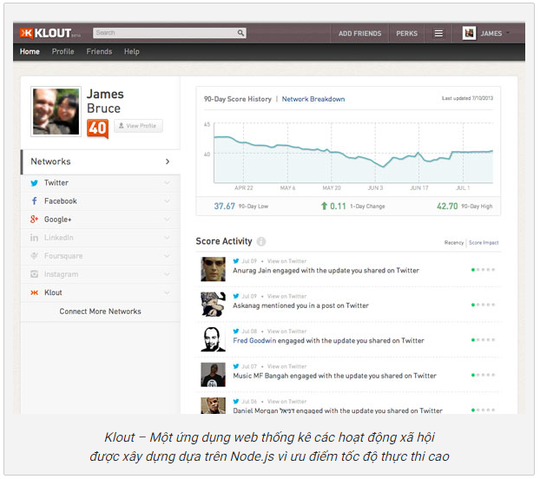

<https://techmaster.vn/posts/33428/nodejs-la-gi-va-tai-sao-toi-nen-hoc-lap-trinh-nodejs>

* + There scalability network applications easily than using non-blocking I / O (model lightened and efficiency).
  + Using "Callback" for all activities reduce CPU wait time for a number of I / O.
  + Compliance with cloud services, where resources can be added or removed at any time automatically.

<http://www.orientsoftware.net/technologies/node-js>

* With Node.js plenty of good points raised, may find this tool brings great potential for the success of the project. Node.js can improve a number of properties that make the product quality has been a severity of certain quality. So the group decided to choose.

After choosing PHP language, Imagineers team has developed more and more requirements from customer. We analyzed and came to conclusion that PHP is no longer fit for our Vinaswap project. Here are some reasons:

1. Due to our system requirement, the main idea about the website is search and request swapping. Our customer requires to search and request swap fast and have high performance.

2. Scrum team failed to program in PHP due to lack of knowledge with this language and it costs the late schedule our project

3. The scale of the project is larger than what our team had expected so the language and the framework is no longer fit for the project anymore.

After a long time of research, we have found a new technology as NodeJs and compare it to PHP. We see that this language has more advance for our project. At retrospective meeting, our Scrum team decided to change from PHP language to Javascript and Type script. Here are some reasons:

1. Extraordinary faster than PHP because of the event callback mechanism.

2. Primarily, it has single-threaded mechanism, but you can also scale Node app on multi-core system.

3. It has separation of concerns, i.e, separate modules for any operation. It's cleaner for new programmers to understand and easier to maintain.

4. Node.JS is popular, new and fresh.

5. Less or relatively no chances of occurrence of deadlock mechanism.

6. It can use the single as well as multi-threaded application

7. Anyone with another platform background can jump to Node. It has numerous frameworks which can be used as an alternate for other frameworks

8. Node.JS uses JavaScript as front-end as well as back-end language while PHP has to depend on some front-end framework or language.

9. Node has more hosting service provider than PHP.

10.

NodeJS and PHP performance benchmarks comparison example :

Benchmark 1: Simple HTTP Requests

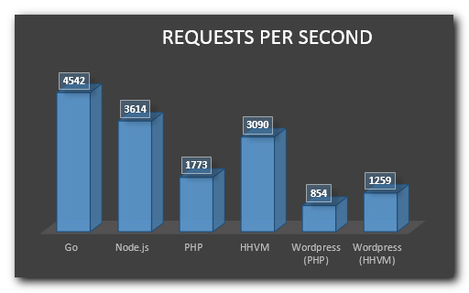

Fig1. Node.js vs. PHP performance and requests handled per second

Notes:

• This HTTP-controlled “hello world” benchmark used Zend PHP 5.6.6 with OPcache enabled.

• The test was done using the Apache ab benchmarking tool.

• The performance of Zend PHP is less than half of Node.js.

• The performance of HHVM is about 74% better than Zend PHP.

• The performance of HHVM is very close to Node.js, but Node.js is still about 17% faster.

• The performance increase when using WordPress with HHVM is about 47%.

Benchmark 2: HTTP + CPU tasks

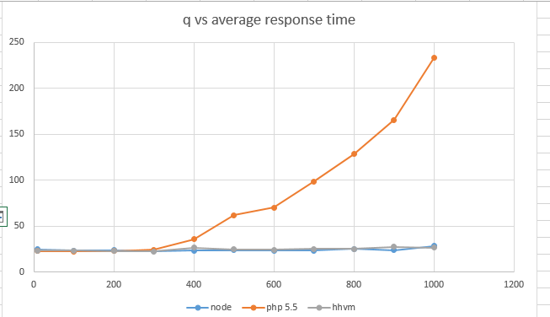

Fig1. Node.js vs. PHP Performance with CPU heavy task of running a bubble sort

Notes:

• This HTTP bubble-sort-job benchmark used Zend PHP 5.5.7 with OPcache enabled.

• The PHP response times degrade rapidly after depleting the available PHP process pool (using a standard maximum of 250 processes on the web server).

• The HHVM performance is similar to Node.js up to 1,000 sort elements, but with 10,000 sort elements, Node.js was about twice as fast HHVM (not visible on this chart).